Chapter 14, Solution 68.

Design a problem to help other students to better understand the design of active highpass filters when specifying a high-frequency gain and a corner frequency.

Although there are many ways to solve this problem, this is an example based on the same kind of problem asked in the third edition.

Problem

Design an active highpass filter with a high-frequency gain of 5 and a corner frequency of 200 Hz.

Solution
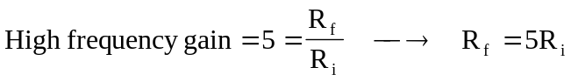
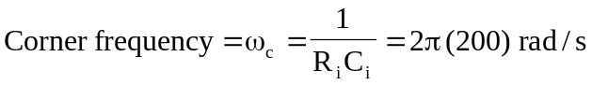

If we select 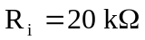, then 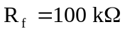 and
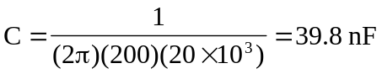

Therefore, if 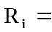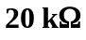, then 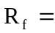 and 